**ASSIGNMENT NO:2**

**THIRD EYE**

* **PROBLEM STATEMENT**

**INTRODUCTION :**

As we are aware of the fact that our life is becoming very fast day by day. Here computer is the most important things that helps us to make human life fast. One computer can do the work of hundreds or thousands people alone. At the same time a computer does the computational work efficiently and correctly.

Third Eye is a menu driven software package. It is a computerized system of the manual job to perform the task. The main feature of this package is that it is user friendly. It requires less maintenance. Moreover easy availability and low cost requirements of the software and hardware used to develop makes the system user friendly.

**PROPOSED SYSTEM :**

* In this system blind person can access function easily through braille keyboard.
* They can learn basic things through computer(via voice command).
* They can learn alphabets,numerics,tables,mathematical funcction(how to add/subtract/multiply/devide two numbers)
* They can listen music as well.
* Teacher or admin can add new function to the system. they can edit the existing data.

**NUMBER OF MODULES AND THEIR DESCRIPTIONS:**

1. Teacher **:**teacher can add new function to the system or they can edit existing data and they will help blind person to solve their queries.
2. Blind person :blind person can learn basic function like alphabets ,tables,numerics,mathematical function through computer voice command ,and they can listen music too.
3. Braille keyboard :braille keyboard is main module of function because braille keyboard gives the instruction to system .

**OBJECTIVES :**

1. reduce manual work to teach blind peoples
2. it is more easy to learn because it is computerized.
3. deletion of wrong data
4. allow to add new data

* **USECASE DIAGRAM :**

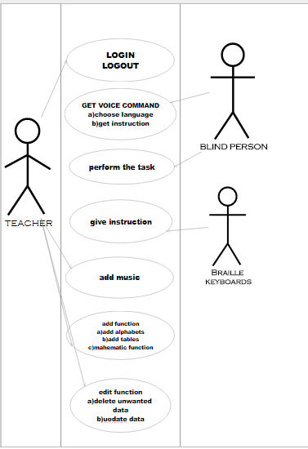

* **USECASE SPECIFICATIONS :**

**Primary actors :**

1. Teacher
2. blind person
3. braille keyboard

**Preconditions :**

* braille keyboard working properly
* systems are working properly and it has appropriate functions

**Basic flow of event :**

1. Teacher enter login id and password
2. teacher is validated
3. teacher add function or edit function(i.e music,alphabets,tables,mathematical function)
4. braille keyboard give instruction
5. blind person get voice command for choosing language
6. blind person select language according to him/her.
7. blind person select function which he/she wants to learn or will select music function to listen music
8. blind person learned basic things through computer.

**Alternative flows :**

2a.teacher is not validated

2a1.system shows error message

3a .wrong information is added.

4a.some keys are not working

4a1.give wrong instruction

6aselect wrong language

6a1.system will do further steps in selected language

6a2.system will ask again for proper language ,rediect to step 4.

7a.select wrong function

7a1 system proceed in selected function

7a2 redirect to step 6 for choosing right option again